*Весна Алексовска,*

*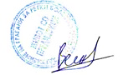Претседател на Здружение на граѓани за ретки болести,*

*ЖИВОТ СО ПРЕДИЗВИЦИ Битола*

*Тел: +389 (0)70 70 54 46*

*Е-маил:* [*zivotsopredizvici@gmail.com*](mailto:zivotsopredizvici@gmail.com) *;* [*vesna.stojmirova@gmail.com*](mailto:vesna.stojmirova@gmail.com)

***Информации за здружението:***

* <http://challenges.mk/>
* <https://www.facebook.com/LifeWithChallengesi>
* <https://www.facebook.com/groups/312483895490987/>
* <https://www.linkedin.com/company/life-with-challenges/>
* <https://www.instagram.com/life_with_challenges_09/>

***ЖИВОТ СО ПРЕДИЗВИЦИ е член на:***

** 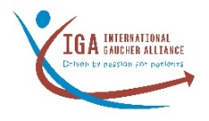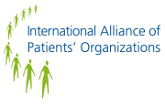 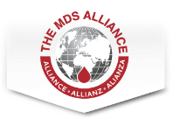 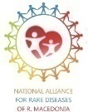

Vesna Aleksovska

President of the Association of citizens for rare diseases

LIFE WITH CHALLENGES Bitola

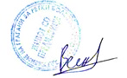Contact: +38970705446 / [zivotsopredizvici@gmail.com](mailto:zivotsopredizvici@gmail.com)

***Information about the association:***

* <http://challenges.mk/>
* <https://www.facebook.com/LifeWithChallengesi>
* <https://www.facebook.com/groups/312483895490987/>
* <https://www.linkedin.com/company/life-with-challenges/>
* <https://www.instagram.com/life_with_challenges_09/>

***Life With Challenges is member of:***

**

***The work of LIFE WITH CHALLENGES is supported by:***

|  |  |
| --- | --- |
| **Name of the Account Holder** | **Association of citizens for rare diseases LIFE WITH CHALLENGES - Bitola (Zdruzenie na gragjani za retki bolesti ZIVOT SO PREDIZVICI - Bitola)** |
| VAT code or Fiscal Code | 4002009513938 |
| Address of the Account Holder | Boris Radosavljevikj – Goce, 12, 7000 Bitola, Republic of North Macedonia |
| Number of the Account for donations out of MK | 0270100381068 |
| IBAN Code | MK07300701003810612 |
| BIC/SWIFT Code | KOBSMK2X |
| Name of the Bank | Komercijalna banka AD Skopje |
| Address of the Bank | Ul. Orce Nikolov br.3, 1000 Skopje, Republic of North Macedonia |
| Transaction account number for MK donations | 300000004663796 |